Record No: 0689
JUANITA ELIZABETH MAUDE SOMERVILLE (Juanita)
of Lucita Farm, Naivasha, Kenya and subsequently Crowe’s Cottage, Dargle Hill, Enniskerry, Co Wicklow

Dau of Reginald Malcolm John Bellingham Somerville (0670) and Maude Gwendolyne Constance
Violet née Moore (0671), only dau of Capt Arthur E H Moore (0672) of the Royal Dublin Fusiliers by
his wife Bertha Emily, nee Campbell.

Birth: 6 July 1932, Eldoret, Kenya
Bapt: 4 Oct 1932, Hoey’s Bridge, Kenya
Marriage: 18 January 1964 at Nairobi, Kenya to Peter Allan Keith Brumby
Death: 9 April 2007 at St Columcille’s Hospital, Loughlinstown, Co Dublin.

Source: Somerville Index

Notes:

Educated: The French School, 1937 - 1939
Bray
Co Wicklow

St George’s Junior School, 1940 - 1942
Onslow Hall,
Shrewsbury.

Moreton Hall, 1942 - 1945
Oswestry.

Hillcourt,
Glenageary, 1945 – 1950
Co Dublin

Ling Physical Training College, 1950 - 1953
Mount St,
Dublin

P E Teaching Moor Park, Ludlow 1953 – 1955
Shute School, Axminster 1955 – 1958
Beaufort School, Camberley 1958 – 1961
Limuru Girls School, Kenya 1961 – 1964

Farming Lucerne, vegetables and dairy produce on the
shores of Lake Naivasha at Lucita Farm
1966 – 1988

Juanita, apart from being an Irish lacrosse international in her youth, had a wide variety of interests and accomplishments, including fishing and shooting, particularly wild fowling in Kenya, flying and diving; she built up a spectacular collection of shells about which she was really knowledgable, collected by herself from the Indian ocean and South Pacific, which is now housed in her nephews’ house in Connemara

She inherited her mother’s vivacity and sociability (and extravagance) and her father’s looks. She broke the heart of many men; was engaged twice, to Michael Tweed of the Gurkha Rifles and Derek Taylor in Canada, before marrying Peter. She brought up Peter’s three children by his previous marriage. They had no children of their own.

Juanita was entirely fearless; tough but naïve. She was one of those people who never really grew up and treated life like a game to be enjoyed no matter what. She was adored by her African neighbours.

She fed her nine dogs from antique Irish coasters, and scooped out their food with a Georgian marrow scoop. So what !! She sold her fine jewellery in the Indian bazaar in Nakuru.

Peter had died in 1986 and by 1988, she realized that vegetable farming on the shore of Lake Naivasha was becoming too difficult. Among other things, the Government’s and civil servants’ corruption led to sudden and unannounced changes in the law. One day she found she was breaking the law, introduced that day, if there was such a law, banning the sale of onions in a certain district. The result was a night in an African gaol without any legal process. Costs were also rising at an alarming pace, unless one joined in the corruption. So she retired to live in a cottage at Dargle Hill where she took up good works: the Wicklow S P C A, the Irish Horse Welfare Trust – for retired or beaten up race horses – and, in particular, S S A F A and the Royal British Legion where she collected more money for poppies than any other in Ireland; but she left her heart in Kenya.

Fiercely independent, she didn’t respond to medical advice, and developed diabetes which ultimately got the better of her. Her body was cremated and her ashes scattered over Lake Naivasha, from the air, by her step son, Russell, and her friend Barry Gaymer of Crescent Island, Naivasha.

Source: WBRBS from personal knowledge

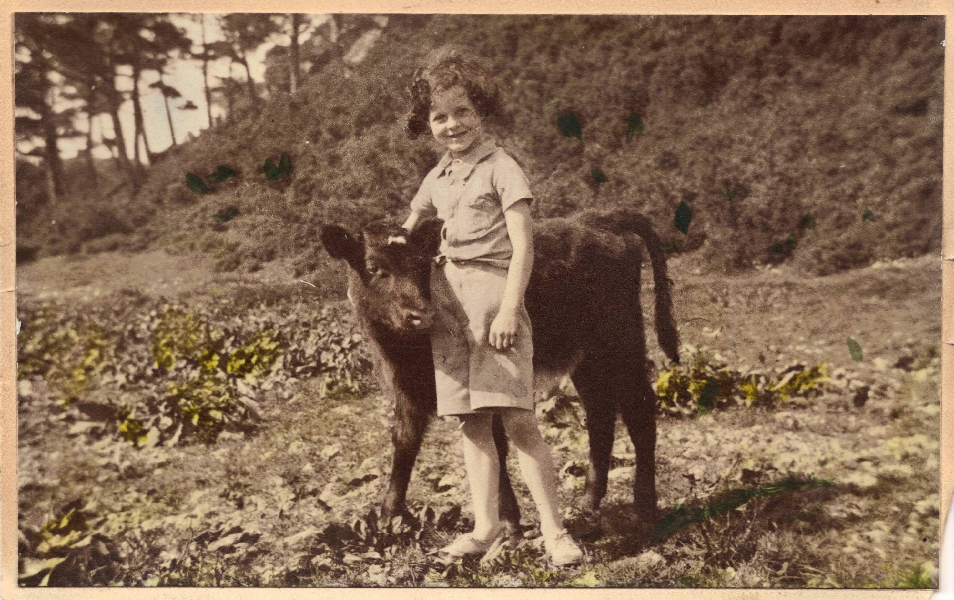
Juanita at Ruwenzori, Delgany about 1938

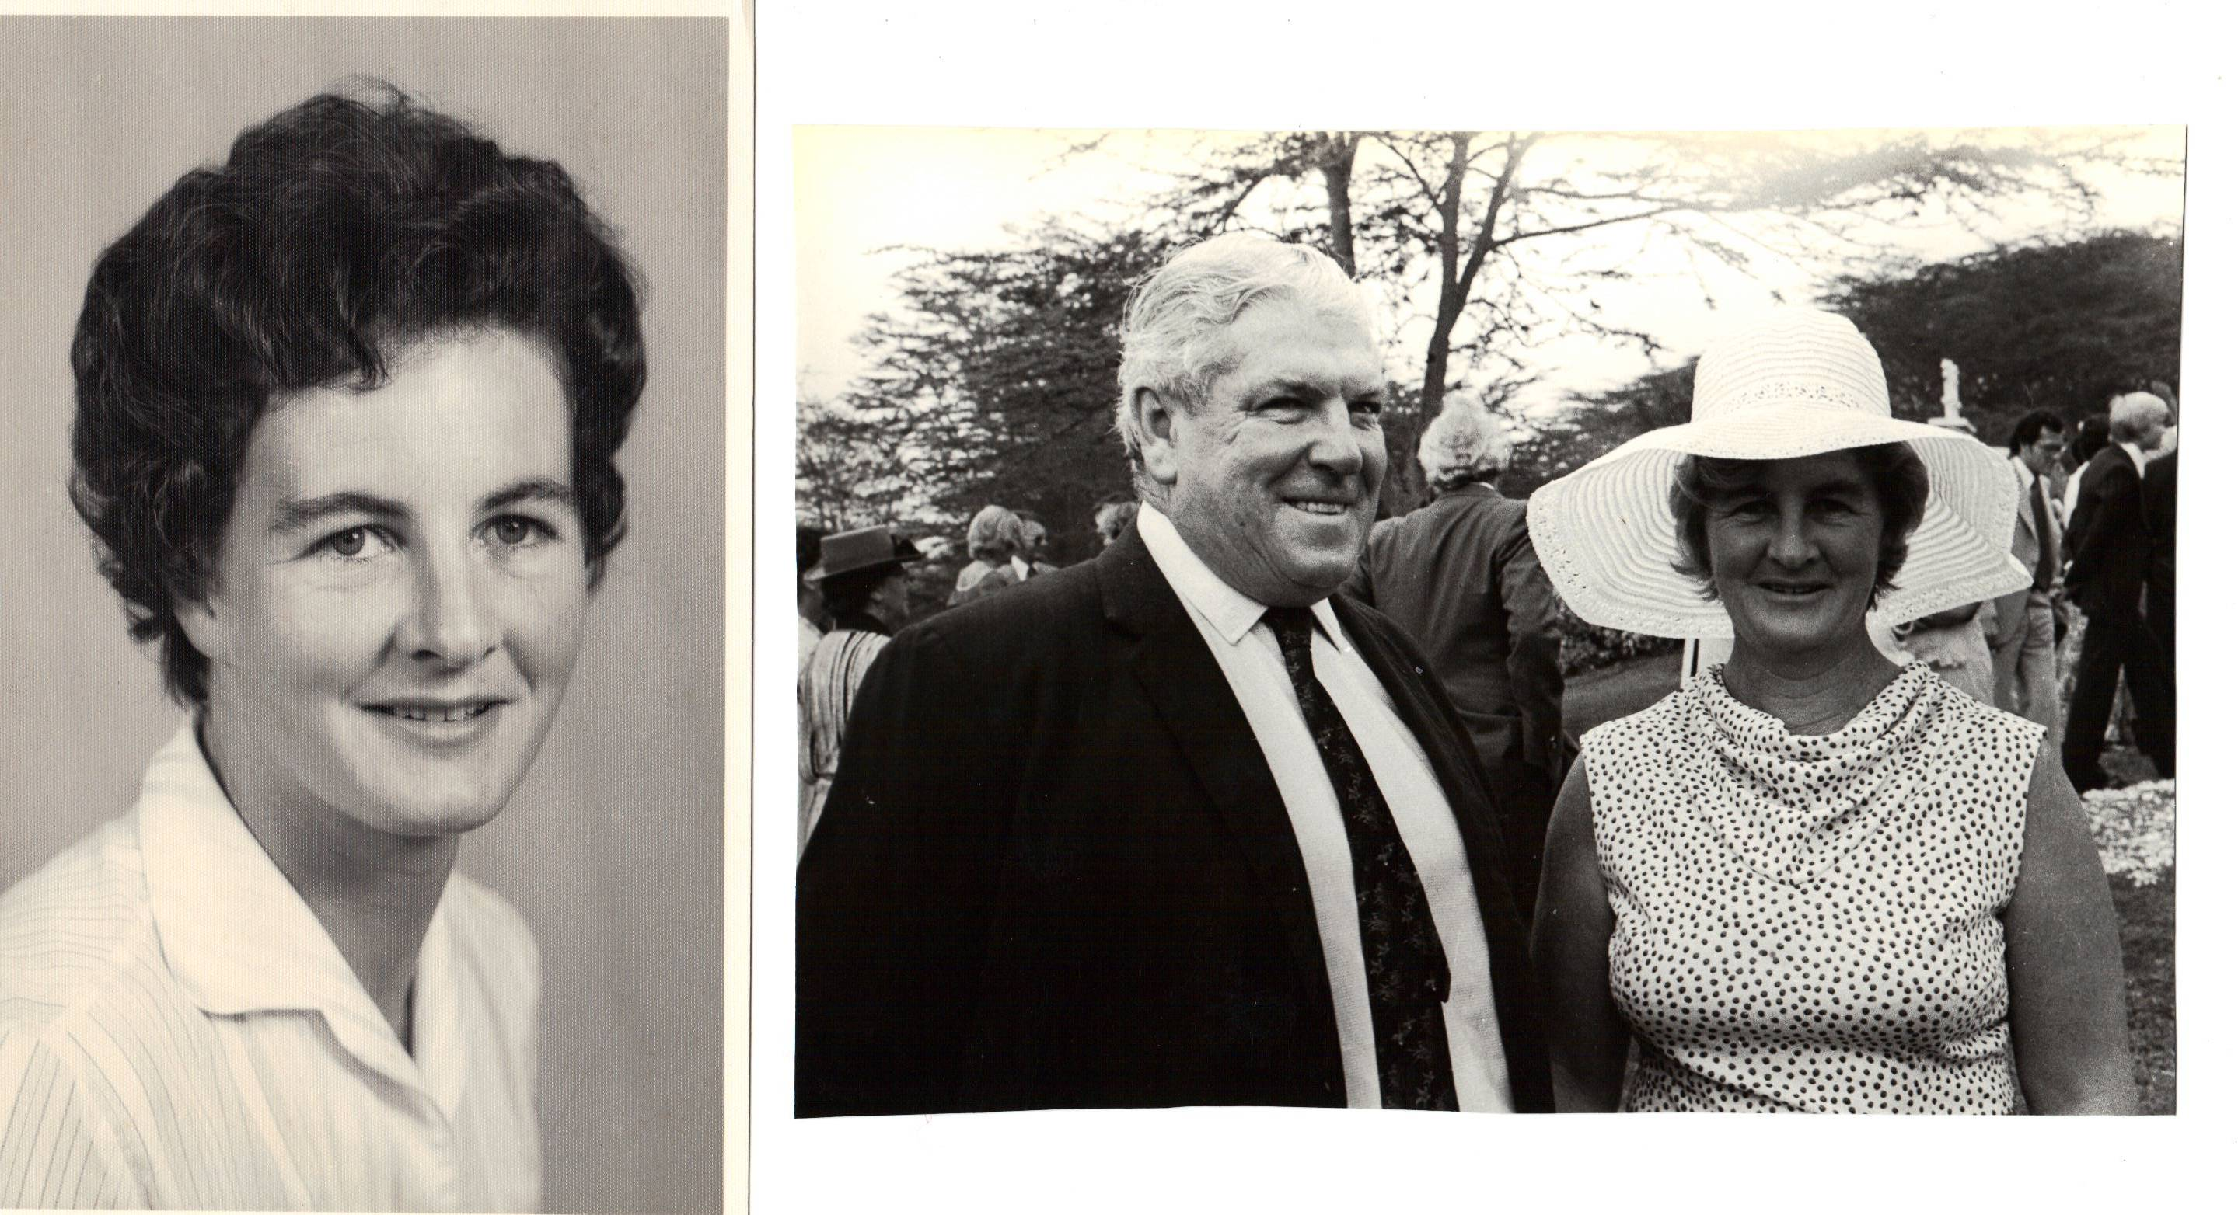
Juanita about 1957
Peter Brumby and Juanita at their wedding in Nairobi 18th January, 1964

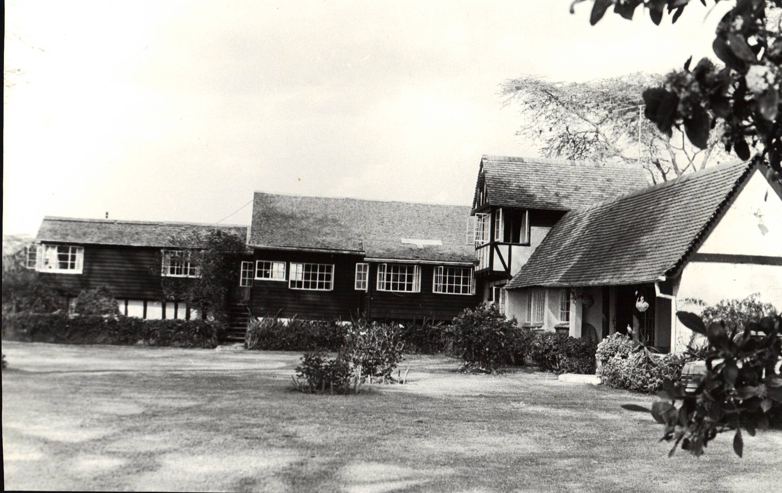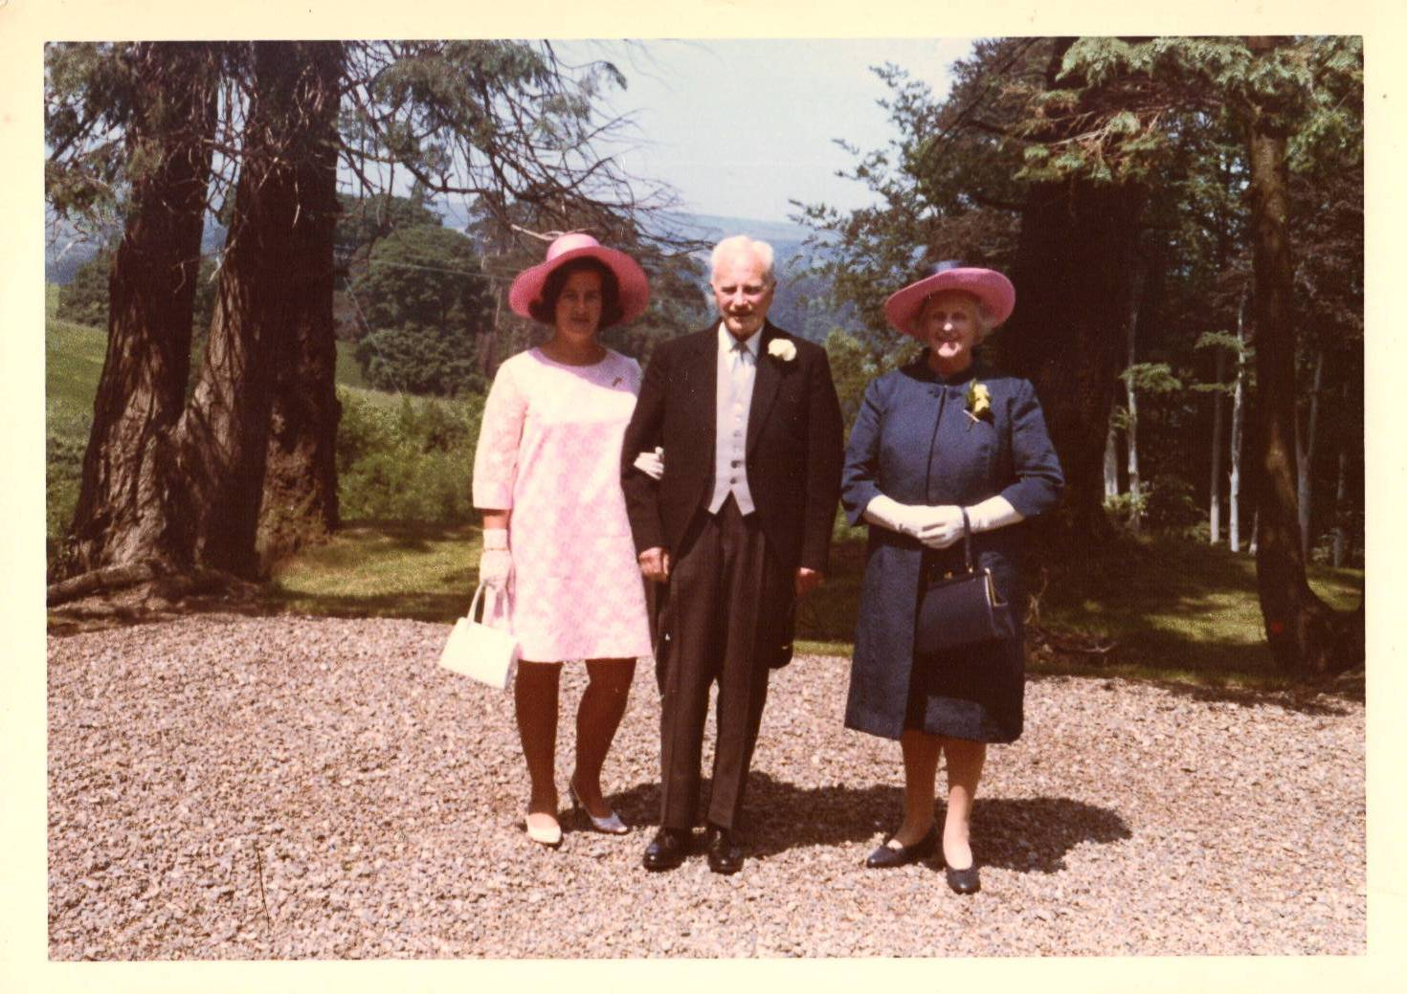
Juanita’s farmhouse at Lucita, Naivasha, Kenya.
Juanita with Reggie and Honor outside St. Patrick’s Church, Enniskerry before the wedding of W.B.R.B.S and Manon, 15th June, 1968.

